**ECE251**

# **Signals and System Fundamentals**

# **Presented to Dr. Michael Ibrahim**

### **George Welson 20P3831 questions:[1,2,3,4,5]**

### **Zeina Hesham 2000320 questions:[6,7,8,9,10]**

### **Farida Elhusseiny 20P6022 questions:[11,12,13,14,15]**

### **Hassan El-Tobgy 20P6173 questions:[16,17,18,19,20]**

### **Mazen El-Saied 20P5893 questions:[21,22,23,24,25]**

\***Contribution of each team member is mentioned next to name and ID**

**Question 1**

X2(t) RE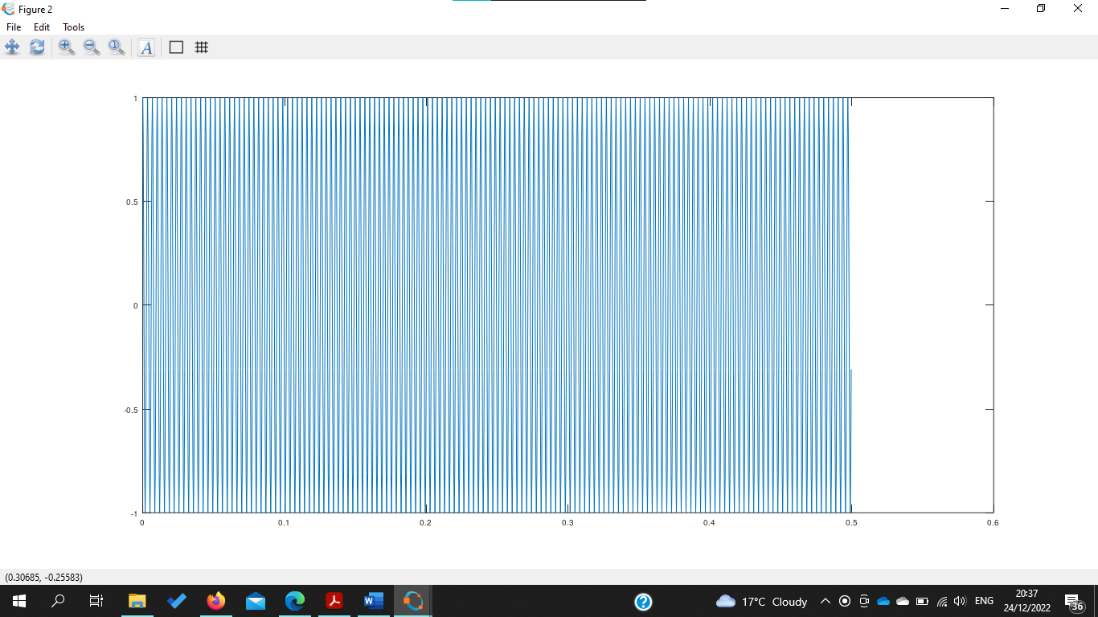

X3(t) MI

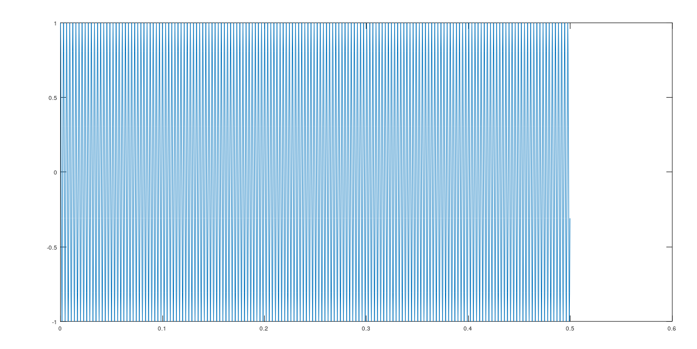

X4(t) FA

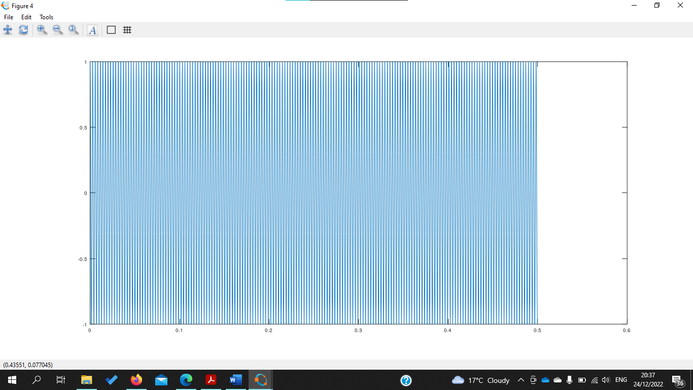

**Question 2**

**Question 3**

X(t)

**Question 5**

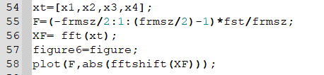

X(F)

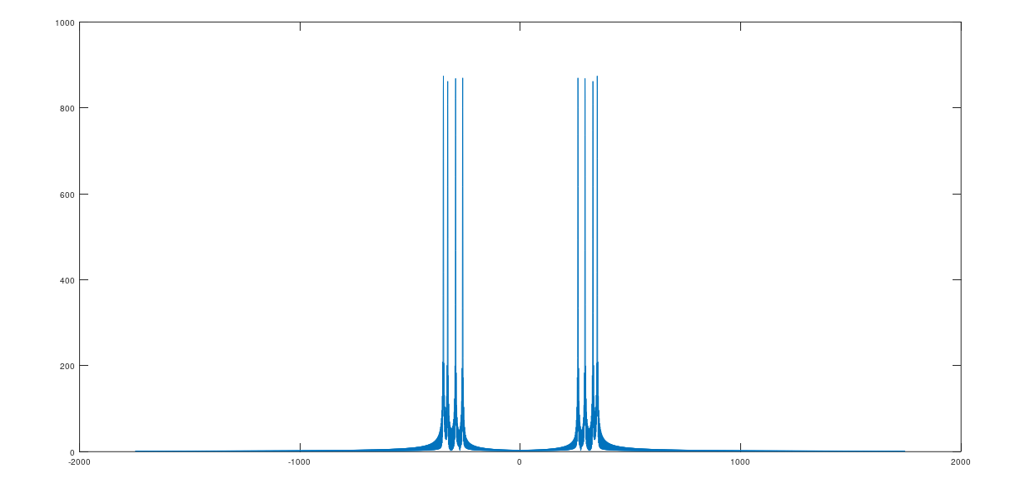

**Question 8 and 11**



**Question 9**

Low pass filter

**Question 10 and 12**

**y1(t)**

**Question 14,15**

Y1(F)

**Question 17-25**

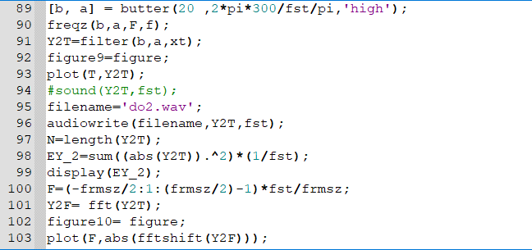

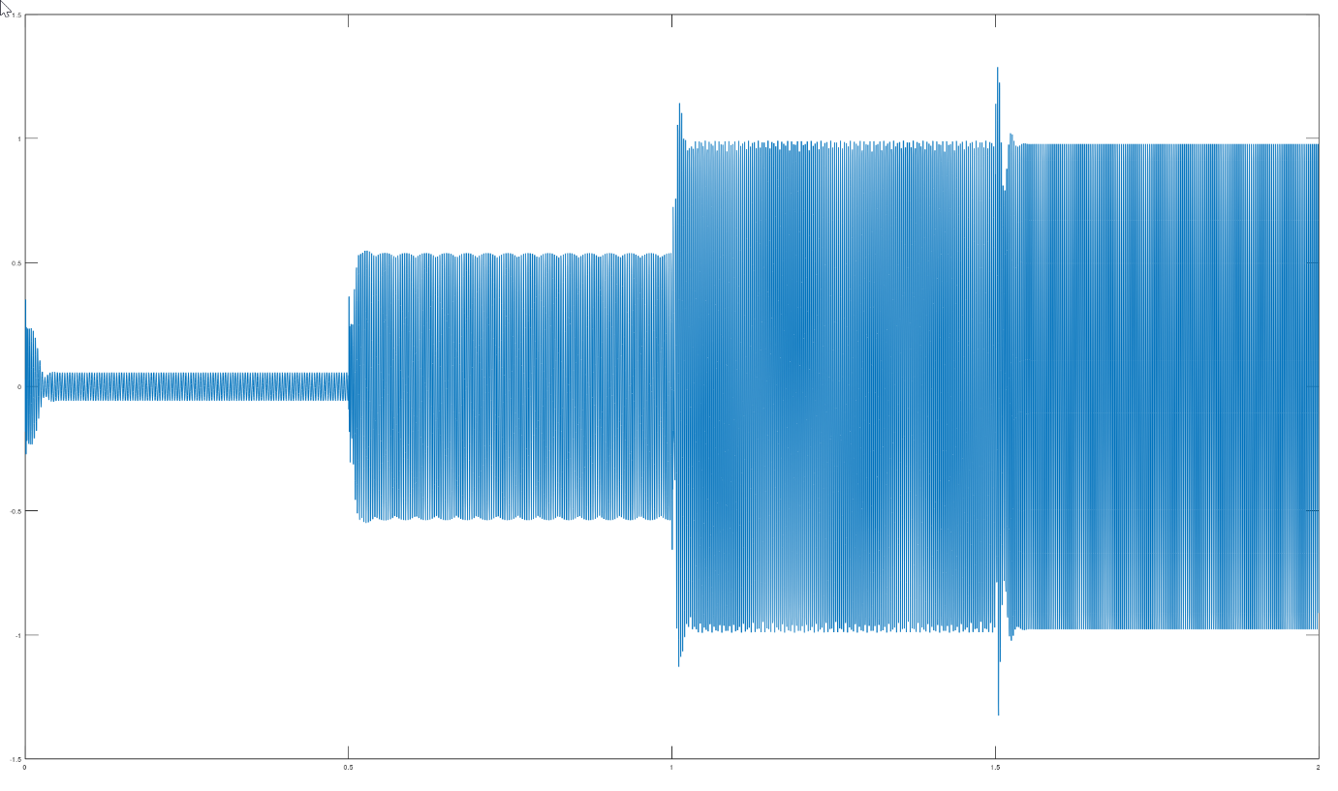**y2(t)**

Y2(F)

Energy values of E(x(t)),E(y1(t)),E(y2(t)) respectively

